**Algebra 2 HW #4 – WS Linear Programming & Review (Part 1) Name: ________________________ Period _______**

1. 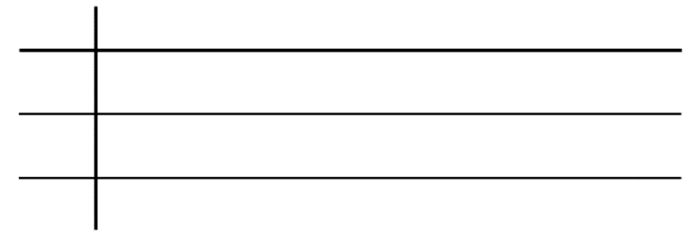**For Algebra 2 you need to budget your time between homework A. ORGANIZE GIVEN INFORMATION.  
   and study per week. You are working with the following constraints.**
   * You have at most 24 hours of time.
   * You have 27 hours of dedicated focus
   * You can only handle 40 problems

**Homework takes 1 hour of time, 2 hours of focus, and 5 problems.**

**Study takes 3 hours of time, 3 hours of focus, and 2 problems.**

**B. WRITE EQUATIONS OR INEQUALITIES USING GIVEN INFORMATION. C. GRAPH THE SYSTEM.**



**Time____________________________________________________**

**____________________________________________________**

**____________________________________________________**

**D. FIND THE COORDINATES OF EACH VERTEX.**

**( , ) ( , ) ( , ) ( , )**

**E. FIND THE BEST USE OF TIME:**

**____________________________________________________**

**____________________________________________________**

**Algebra 2 HW #4 – WS Linear Programming & Review (Part 1) Name: ________________________ Period _______**

1. **For Algebra 2 you need to budget your time between homework A. ORGANIZE GIVEN INFORMATION.  
   and study per week. You are working with the following constraints.**
   * You have at most 24 hours of time.
   * You have 27 hours of dedicated focus
   * You can only handle 40 problems

**Homework takes 1 hour of time, 2 hours of focus, and 5 problems**

**per hour. Study takes 3 hours of time, 3 hours of focus, and 2 problems**

**can be completed per hour.**

**B. WRITE EQUATIONS OR INEQUALITIES USING GIVEN INFORMATION. C. GRAPH THE SYSTEM.**



**____________________________________________________**

**____________________________________________________**

**____________________________________________________**

**D. FIND THE COORDINATES OF EACH VERTEX.**

**( , ) ( , ) ( , ) ( , )**

**E. FIND THE BEST USE OF TIME:**

**____________________________________________________**

**____________________________________________________**

1. **What inequalities describe the region graphed? 3. Graph the system of inequalities and clearly mark your solutions.**

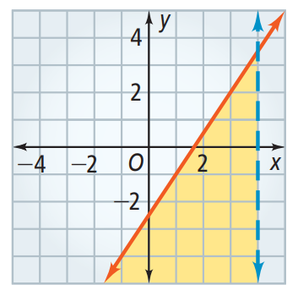

y < (x – 4)2 – 5  
y > –|x + 3| + 5



1. **Solve each inequality and graph the solutions on a number line.**
2. 9|x + 8| + 10 < 55 **b)** 4x2 + 8 > 33x
3. **What inequalities describe the region graphed? 3. Graph the system of inequalities and clearly mark your solutions.**



y < (x – 4)2 – 5  
y > –|x + 3| + 5



1. **Solve each inequality and graph the solutions on a number line.**
2. 9|x + 8| + 10 < 55 **b)** 4x2 + 8 > 33x