CH 1 TOPICS
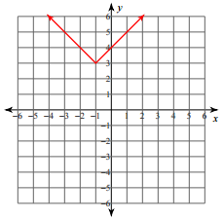
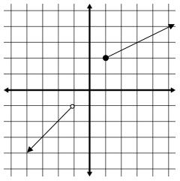
- State the domain and range of the function. Write your answers in interval notation.
a) Domain b) Domain

_________________ _________________

Range Range

_________________ _________________

CH 2 TOPICS
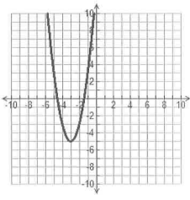
- Write the equation and label the locator point of each graph below. Don’t forget to find the a-value. (LP = locator point)
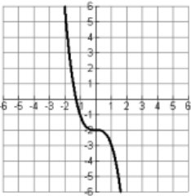
a) b)
Parent Equation: ______ Parent Equation: ______

y = _________________ y = _________________

LP: _________________ LP: _________________

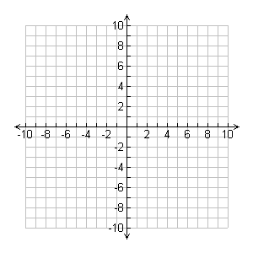
- Sketch the parent graph of each equation and then in a second color the transformation on the axes provided. Name the locator point and dash in any asymptotes. Describe the transformation of the graph compared to the parent graph.
a) (x + 2)² + (y + 3)² = 4 b) y = 2(x – 1)² – 3

LP: LP:
Description: Description:

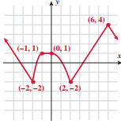
- a) For the “parent graph” y = f(x), describe the transformation below. Sketch the graph of the new equation on the same axes.

y = f(x + 1) - 3

Description

b) A-aron flipped the function over the x-axis and shifted it 2 units down.
Write the function notation A-aron should use to express the transformation.

- The parabolic opening to a tunnel is 32 m wide measuring from side to side along the ground. It reaches a height of 14 m at its highest point. Determine the equation of the function that models the opening to the tunnel, and draw a diagram of the situation with clearly labeled key ordered pairs.

- Ray Guy, the Oakland Raiders punter, holds the record for the longest “hang time” (the amount of time the football stays in the air) for a punt in the National Football League (NFL) at 8 seconds. It is considered a good punt if the “hang time” lasts longer than 4.5 seconds. If a punter kicks a football with an upward velocity of 70ft/sec. and his foot meets the ball at 3 feet above the ground, the function 𝑦 = −16𝑥² + 70𝑥 + 3 represents the height of the ball 𝑦 in feet after 𝑥 seconds.
- How high was the football after 2 seconds? a) ____________
- How long does it take for the ball to hit the ground? b) ____________
- When was the football 57 feet in the air? c) ____________
- How high was the football at its maximum height? d) ____________
- When did the football reach its maximum height? e) ____________

- Find the vertex, the equation of the axis of symmetry, the coordinates of the x-intercept(s) if there are any, and the coordinate of the y-intercept, for the following by completing the square. Then graph the equation (at least 5 points!).
y = x² – 6x + 9

Vertex: ___________
Equation of the axis of symmetry: ___________
x – intercepts: ___________
y – intercepts: ___________

- Put the following in graphing form by completing the square and then graph the circle. Identify the radius and the center of the circle.
x² + y² – 10x + 2y + 17 = 0

** DON’T FORGET TO LOOK OVER PIECEWISE FUNCTIONS!!! GRAPHING & EVALUATING!!! **

